BIODATA: sarang shankar vasudev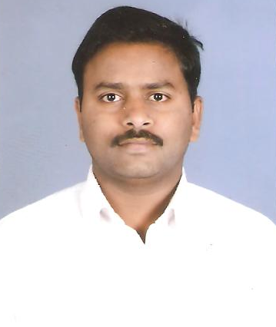

1. Name : Mr. Shankar V Sarang.
2. Postal address for correspondence : Department of Agrochemicals and Pest
Management, Shivaji University, Kolhapur
Email: shankarsarang27@gmail.com
Mobile: 9325985727
3. Date of Birth : 27th Feb 1983
4. Present Employment : Contributory Teacher & Research
Student (Ph.D)
5. Nationality : Indian

6. Marital status : Unmarried

- Academic Qualification :

Sr.No | Examination | Board/University | Year | Percentage | Grade
 | Ph.D | Shivaji University, Kolhapur | Ongoing | Appeared
 | M.Sc | Shivaji University, Kolhapur | 2005 | 61.25% | A
 | B.Sc | Mumbai University, Mumbai | 2003 | 62.50% | A
 | H.S.C | Maharashtra State Board of Secondary & Higher Secondary Education,Pune | 2000 | 48.33% | B
 | S.S.C | Maharashtra State Board of Secondary & Higher Secondary Education,Pune | 1998 | 55.86% | B⁺

- Title of the thesis : “Allelopathic effects of Wrightia tinctoria and Andrographis paniculata on growth and metabolism of some dicot weeds.”

- Awards & Hounors : -------

- Industrial Training: Maharashtra insecticide Ltd Akola.

5. Academic Project: “Efficacy of different insecticides against mango hopper.”

- Computer Knowledge : Microsoft word, Excel, PowerPoint

- Work Experience: Worked as Contributory lecturer & Teaching Assistant from
2008 to till day.

- Research Specialization : Allelopathy

- List of the Publications : 2

(1) “Evaluation of anti-microbial activity in acacia catechu willd.” published
in journal Biopesticides.

(2) “Anti-microbial activity of Barringtonia acutangula L.” published in
journal Bioinfolet.

- Participation in National & International Symposium:

- Participated in One day National seminar on “New Trends in Pest Mangement” on 31st Jan, 2014 at Dept of agrochemicals & Pest Management, Shivaji University, Kolhapur.

- Participated in One day National Workshop on “Recent Advances in Agrochemicals” on 28th Feb, 2012 at Dept of Agrochemicals & Pest Management, Shivaji University, Kolhapur, Maharashtra.

- Participated in Two days National Workshop on “Research writings, ethics, plagiarism and publishability” on 26th and 27th July, 2012 organised by internal quality cell (IQAC) Shivaji University, Kolhapur, Maharashtra.

- Participated in One day National Workshop on “Instrumentation awareness programme in researchers to promote research activities” on 22 Feb. 2011 at New college Kolhapur,

- Participated in Three days Workshop on “Analytical instruments techniques” on 18 march 2009 to 20 march 2009 at University Science instrumentation centre, Shivaji University, Kolhapur.

